RETAIL STORE SALES PERFORMANCE ANALYSIS USING IBM COGNOS ANALYTICS
A
PROJECT REPORT
SUBMITTED BY
AMBIKA MISHRA
ROLL NO: 25050020005
MASTER OF BUSINESS ADMINISTRATION
IN
MBA – IBM
SESSION 2026-2027
UNDER THE GUIDANCE OF
MR. FERHAN
IBM Trainer


Rawatpur, Prayagraj, Uttar Pradesh 211012

ACKNOWLEDGEMENT
I would like to express my sincere gratitude to United University, Prayagraj, Uttar Pradesh, for giving me the opportunity to undertake this project titled “Retail Store Sales Performance Analysis Using IBM Cognos Analytics” as part of my MBA – IBM programme for the academic session 2026–2027.
First and foremost, I would like to express my heartfelt thanks to my IBM Trainer, Mr. Farhan, for his valuable guidance, support and encouragement throughout this project. His teaching helped me understand the practical use of IBM Cognos Analytics and the importance of data visualization in business decision-making. His support motivated me to explore data analysis and dashboard development in a structured manner.
I am also grateful to the Faculty of Commerce and Management at United University for providing the academic environment and learning opportunities needed to complete this project. The knowledge gained during my MBA programme helped me understand the relationship between retail management, sales analysis and business intelligence.
This project gave me practical experience in data preparation, data visualization, dashboard creation and the interpretation of business data. It also strengthened my analytical thinking and showed me how data-driven insights can support better decisions in the retail industry.
I would also like to thank my teachers, classmates and everyone who directly or indirectly supported me during this work. Finally, I am deeply thankful to my parents for their continuous encouragement, motivation and support throughout my academic journey.
AMBIKA MISHRA
Roll No: 25050020005
MBA – IBM, United University, Prayagraj
ABSTRACT
The project entitled “Retail Store Sales Performance Analysis Using IBM Cognos Analytics” focuses on analysing the sales data of a multi-store retail business to understand sales performance, product profitability and customer purchasing patterns. The main objective is to convert raw transaction data into meaningful information through descriptive analytics and data visualization.
Microsoft Excel was used to prepare the dataset and IBM Cognos Analytics was used to build interactive visualizations and a dashboard. The dataset contains 600 order records for the year 2025 from five store locations (Prayagraj, Lucknow, Varanasi, Kanpur and Delhi NCR). It includes product category, quantity, unit price, discount, net sales, profit, payment method, customer type, sales channel and customer rating.
The analysis shows total net sales of ₹21.37 lakh and total profit of ₹3.58 lakh, giving an overall profit margin of 16.8%. Electronics generated the highest sales while Apparel gave the best profit margin. Repeat customers contributed most of the revenue, UPI was the most used payment method and October was the best sales month. A simple linear trend model was also used to forecast sales for the next three months.
The findings help retail managers decide on inventory, discount policy, store-level targets and customer retention strategy.
Keywords: Retail Analytics, Sales Performance, Descriptive Analytics, IBM Cognos Analytics, Data Visualization, Dashboard, KPI, Sales Forecast.
TABLE OF CONTENTS
S.No | Content
1 | Title Page
2 | Acknowledgement
3 | Abstract
4 | Table of Contents
5 | List of Figures and Tables
6 | 1. Introduction
7 | 2. Problem Statement
8 | 3. Data Discussion
9 | 4. Method, Tools & Technologies Used
10 | 5. Project Workflow
11 | 6. Procedure
12 | 7. Results / Predictive Model
13 | 8. Insights (Observations)
14 | 9. Recommendations / Suggestions
15 | 10. Conclusion and Future Scope
16 | Glossary of Terms
17 | References
18 | Appendix – Sample Dataset

LIST OF FIGURES AND TABLES
Figure | Title
Figure 1 | Workflow of the Project
Figure 2 | Cognos Dashboard – Overview
Figure 3 | Net Sales by Product Category
Figure 4 | Monthly Net Sales Trend
Figure 5 | Net Sales by Store Location
Figure 6 | Orders by Payment Method
Figure 7 | Sales: New vs Repeat Customers
Figure 8 | Sales by Sales Channel
Figure 9 | Profit Margin by Category
Figure 10 | Discount Level vs Profit Margin
Figure 11 | Customer Rating Distribution
Figure 12 | Sales Forecast using Linear Trend

1. INTRODUCTION

1.1 Introduction
Retail is one of the largest and fastest-changing sectors of the Indian economy. From neighbourhood stores to large supermarket chains, retailers sell thousands of products every day to customers who differ in age, income, taste and shopping habits. Every sale creates a record: what was sold, where, when, at what price, with what discount and how the customer paid. Together these records form a large body of data about the business.
However, raw data does not help unless it is organised and presented in a simple form. A store manager cannot read six hundred rows of a spreadsheet and decide which product to stock more or which store needs support. This is where Business Intelligence (BI) tools become useful. They convert raw data into charts, tables, dashboards and Key Performance Indicators (KPIs) that can be understood at a glance.
IBM Cognos Analytics is one of the leading BI platforms in the world. It allows users to upload data, build a data model, create visualizations, combine them into dashboards and share the findings with decision makers. It also has built-in features such as forecasting, which helps in estimating future values from past trends.
This project, “Retail Store Sales Performance Analysis Using IBM Cognos Analytics”, uses a retail sales dataset to study the performance of five stores across seven product categories during the year 2025. Microsoft Excel is used to prepare the data and IBM Cognos Analytics is used to create visualizations and a dashboard.

1.2 Background of the Study
Modern retail businesses compete on price, convenience and customer experience. Retailers therefore need to know which products bring profit, which stores perform well, which months are busy and how customers prefer to pay. Descriptive analytics answers these “what happened” questions by summarising historical data using totals, counts, averages and comparisons.
When descriptive analytics is combined with visual presentation, the result is easy to understand even for non-technical users. A bar chart can show the strongest category in seconds, a line chart can show the seasonal pattern and a pie chart can show the share of each payment method. This is the approach followed in this project.

1.3 Objectives of the Study
- To create a structured retail sales dataset suitable for analysis.
- To analyse net sales and profit by product category, store, month and customer type.
- To study customer behaviour in terms of payment method, sales channel, repeat purchase and ratings.
- To understand the effect of discounts on profit margin.
- To build visualizations and a dashboard using IBM Cognos Analytics.
- To forecast sales for the next three months using a simple trend model.
- To give practical recommendations to improve sales and profitability.

1.4 Scope of the Study
The study covers 600 sales orders of a retail business with five stores in Uttar Pradesh and Delhi NCR for the period January to December 2025. It is limited to descriptive analysis and a basic forecast. It does not include supplier data, employee data, store rent or other operating costs. The dataset is a created (simulated) dataset prepared for academic learning, but its structure follows real retail transaction data.

1.5 Significance of the Study
The project is useful for students because it shows the complete journey from raw data to dashboard. It is useful for retail managers because it shows how simple analysis can guide decisions on stock, pricing and promotion. It also shows how a tool like IBM Cognos Analytics can be used without advanced programming knowledge.

1.6 Organisation of the Report
Chapter 2 states the problem. Chapter 3 describes the data. Chapter 4 explains the methods, tools and technologies. Chapter 5 presents the workflow and Chapter 6 explains the procedure followed in IBM Cognos Analytics. Chapter 7 presents the results and the predictive model. Chapter 8 gives the insights, Chapter 9 gives recommendations and Chapter 10 concludes the report with future scope.

2. PROBLEM STATEMENT

2.1 Background of the Problem
A retail business with several stores generates daily sales data in many forms: billing software, payment apps, online order forms and customer feedback sheets. When this data stays in separate files, managers depend on guesswork or on lengthy manual reports. Decisions about stock, discounts and store targets are then delayed or taken on the basis of experience alone.
Retailers commonly face problems such as stocking too much of a slow-moving product, giving high discounts that reduce profit, not knowing which store is weak and not knowing which customers are loyal. These problems cannot be solved unless the sales data is analysed in a clear and visual way.

2.2 Problem Statement
Problem Statement
A multi-store retail business has transaction data but no simple visual system to understand its sales performance. The management cannot easily identify the best and weakest categories and stores, the effect of discounts on profit, the seasonal pattern of sales and the behaviour of its customers. This project aims to solve the problem by analysing the sales data and building an interactive dashboard in IBM Cognos Analytics.

2.3 Key Questions to be Answered
- Which product categories bring the highest sales and which give the highest profit margin?
- Which store locations perform best and which need improvement?
- How do sales change from month to month and which months are the strongest?
- How much do repeat customers contribute compared with new customers?
- Which payment methods and sales channels are most popular?
- How do discounts affect profit margin?
- What are the expected sales for the next three months?

2.4 Need for the Study
Without analysis, a retailer may focus on a category that looks big in sales but gives very little profit. For example, a grocery counter may be crowded with customers but may earn a much smaller margin than a small apparel section. Only a structured analysis can reveal such differences and help managers allocate shelf space, staff time and marketing money wisely.

2.5 Limitations of the Study
- The dataset is created for academic purposes and covers a single year.
- Only descriptive analysis and a simple linear trend forecast are used.
- Operating costs such as rent and salaries are not included, so profit means gross profit on sales.
- Customer-level details such as age and income are not included.

3. DATA DISCUSSION

3.1 Source and Nature of Data
The data used in this project is a created dataset of 600 retail sales orders. It was prepared in Microsoft Excel and saved in CSV/XLSX format. Each row represents one order and each column represents one characteristic of that order. Values were generated with realistic price ranges, discount slabs, festive-season effects and store-wise demand so that the dataset behaves like real retail data.
The year 2025 is covered. Festive months (September to November) were given a higher number of orders and slightly higher discounts to reflect the Navratri–Diwali shopping season in India.

3.2 Data Dictionary
Table 1: Description of dataset fields
Field | Type | Description
OrderID | Text | Unique order number (RS1001–RS1600)
OrderDate | Date | Date of purchase (2025)
Store | Text | Store location: Prayagraj, Lucknow, Varanasi, Kanpur, Delhi NCR
Region | Text | East, Central or North
Category | Text | Product category (7 categories)
Product | Text | Name of the product sold
Quantity | Number | Units purchased in the order
UnitPrice | Number | Selling price per unit before discount (₹)
DiscountPct | Number | Discount given on the order (%)
NetSales | Number | Amount received after discount (₹)
Profit | Number | Gross profit earned on the order (₹)
PaymentMethod | Text | UPI, Debit Card, Credit Card, Cash or Wallet
CustomerType | Text | New or Repeat customer
Channel | Text | In-store or Online Order
Rating | Number | Customer rating from 1 to 5

3.3 Summary of the Dataset
Table 2: Key figures of the dataset
Measure | Value
Total orders | 600
Total units sold | 1,215
Total net sales | ₹21,37,219
Total profit | ₹3,58,286
Overall profit margin | 16.8%
Average order value | ₹3,562
Average customer rating | 3.94 / 5
Number of stores | 5
Number of product categories | 7

3.4 Category-wise Summary
Table 3: Sales, orders and margin by product category
Category | Orders | Net Sales (₹) | Share | Margin
Electronics | 89 | 6,79,830 | 31.8% | 9.0%
Home & Kitchen | 88 | 4,80,163 | 22.5% | 19.9%
Apparel | 105 | 3,79,101 | 17.7% | 27.3%
Footwear | 52 | 2,01,545 | 9.4% | 22.1%
Grocery | 186 | 1,89,362 | 8.9% | 5.5%
Beauty & Personal Care | 50 | 1,04,017 | 4.9% | 24.5%
Sports & Fitness | 30 | 1,03,201 | 4.8% | 17.0%

3.5 Data Quality and Preparation
Before loading into IBM Cognos Analytics, the dataset was checked for common data problems. Each column was given a correct data type (date, number or text). Duplicate order numbers were checked and none were found. Blank cells were checked and none were found. Discount values were limited to fixed slabs and ratings were limited to the 1–5 range. Text values such as store names and category names were written in one consistent spelling so that Cognos does not treat the same value as two different items.
The calculated field NetSales was derived as Quantity × UnitPrice × (1 − Discount%). The Profit field was derived from category-wise margin rules adjusted for discount. These checks ensure that the visualizations show correct and reliable figures.

3.6 Sample of the Dataset
The first ten records of the dataset are shown below. The full dataset is attached in the appendix and as a separate Excel file.
Table 4: First ten records of the dataset
Order | Date | Store | Category | Qty | Disc | Net Sales | Profit | Payment | Cust. | Rtg
RS1001 | 01-01 | Lucknow | Footwear | 2 | 20.0% | 2,186 | 343 | Debit Card | Repeat | 4
RS1002 | 01-03 | Kanpur | Grocery | 2 | 10.0% | 693 | 31 | Credit Card | New | 3
RS1003 | 01-04 | Prayagraj | Grocery | 3 | 15.0% | 393 | -12 | Cash | New | 5
RS1004 | 01-05 | Delhi NCR | Electronics | 2 | 5.0% | 3,344 | 291 | Credit Card | Repeat | 4
RS1005 | 01-05 | Kanpur | Sports | 2 | 5.0% | 3,422 | 640 | UPI | Repeat | 2
RS1006 | 01-06 | Lucknow | Grocery | 4 | 0.0% | 2,420 | 56 | Cash | Repeat | 3
RS1007 | 01-06 | Kanpur | Footwear | 1 | 10.0% | 2,487 | 475 | Debit Card | Repeat | 4
RS1008 | 01-08 | Prayagraj | Grocery | 1 | 0.0% | 223 | 24 | UPI | Repeat | 4
RS1009 | 01-09 | Prayagraj | Beauty & PC | 2 | 20.0% | 2,117 | 340 | UPI | Repeat | 3
RS1010 | 01-10 | Prayagraj | Apparel | 3 | 0.0% | 8,715 | 2,353 | Cash | New | 2

4. METHOD, TOOLS & TECHNOLOGIES USED

4.1 Research Approach
The project follows a descriptive and quantitative research approach. Descriptive analytics is used to summarise what has already happened in the business. A simple predictive method is added at the end to estimate future sales. No complex statistical or machine learning model is used, because the purpose of the project is business understanding through visualization.

4.2 Methods Used
- Descriptive statistics: totals, counts, averages and percentage shares were calculated for sales, profit and orders.
- Comparative analysis: categories, stores, payment methods and customer types were compared against each other.
- Trend analysis: monthly sales were plotted to find seasonality and peak months.
- Profitability analysis: profit margin was calculated as Profit ÷ Net Sales × 100 for each category and discount level.
- Linear trend forecasting: a straight line was fitted to monthly sales (Sales = a + b × month) to predict the next three months.
- KPI monitoring: headline figures such as net sales, profit, orders and average rating were displayed as KPI tiles.

4.3 Tools and Technologies
Table 5: Tools used in the project
Tool | Purpose
Microsoft Excel | Creating, cleaning and validating the dataset; calculating NetSales and Profit
IBM Cognos Analytics | Uploading data, creating the data module, building visualizations and the dashboard, forecasting
CSV / XLSX format | Storing the dataset in a form accepted by Cognos
Python (optional support) | Checking totals and drawing supporting charts for the report
Microsoft Word | Preparing the final project report

4.4 About IBM Cognos Analytics
IBM Cognos Analytics is a web-based business intelligence and reporting platform. It lets a user work in a browser without installing heavy software. The main features used in this project are listed below.
- Data upload: Excel and CSV files can be uploaded directly and used as data sources.
- Data modules: Fields can be organised, renamed and given correct types; calculations can be added.
- Dashboards: Many visualizations can be placed on one canvas with filters and KPI tiles.
- Visualization types: bar, column, line, pie, donut, map, table, KPI and many others.
- AI assistant and forecasting: Cognos can suggest suitable charts and can add a forecast line to a time series.
- Sharing: Dashboards can be shared as links, exported as PDF or images, or scheduled.

4.5 Key Formulas Used
Table 6: Formulas used in the analysis
Measure | Formula
Net Sales | Quantity × Unit Price × (1 − Discount %)
Profit Margin (%) | Profit ÷ Net Sales × 100
Average Order Value | Total Net Sales ÷ Number of Orders
Share of Category (%) | Category Sales ÷ Total Sales × 100
Trend line | Sales = a + b × Month number

5. PROJECT WORKFLOW

5.1 Overview of the Workflow
The project was carried out in eight connected stages. The output of each stage becomes the input of the next stage. Figure 1 shows the complete workflow.
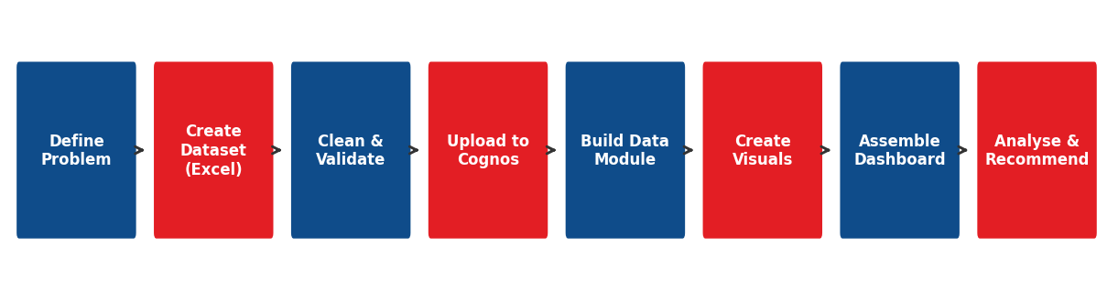
Figure 1: Workflow of the Project

5.2 Step-by-Step Description
- Define the problem: the business problem and the questions to be answered were written down (Chapter 2).
- Create the dataset: a retail dataset of 600 orders with 15 fields was prepared in Excel.
- Clean and validate: data types, duplicates, blanks and spellings were checked.
- Upload to IBM Cognos Analytics: the cleaned file was uploaded as a data source.
- Build the data module: fields were organised and the measures (sales, profit, quantity) were defined.
- Create visualizations: bar, line, pie and table charts were made for each business question.
- Assemble the dashboard: KPI tiles and charts were arranged on a single dashboard with filters.
- Analyse and recommend: results were interpreted and recommendations were prepared.

5.3 Input, Process and Output
Table 7: Input–process–output view of the project
Input | Process | Output
Raw retail sales data (600 orders) | Cleaning, grouping, summarising, charting | Clean dataset and summary tables
Cleaned dataset | Data module and visualization in Cognos | Charts and KPI tiles
Charts and KPIs | Dashboard design and interpretation | Interactive sales dashboard
Monthly sales history | Linear trend model | Three-month sales forecast
Findings | Business reasoning | Insights and recommendations

Following a clear workflow makes the project repeatable. A retailer can replace the dataset with the next year’s data and refresh the same dashboard without rebuilding it.

6. PROCEDURE
This chapter describes how the project was carried out in practice, from preparing the file to publishing the dashboard.

6.1 Step 1 – Preparing the Dataset in Excel
- A new Excel workbook was created with one sheet named “RetailSales”.
- Fifteen column headings were typed in the first row (see Table 1 in Chapter 3).
- Six hundred order rows were entered with dates in the year 2025.
- Formulas were used for NetSales = Quantity × UnitPrice × (1 − Discount/100).
- Filters were applied to each column to check for blank or wrong values.
- The file was saved as Retail_Sales_Dataset.xlsx (and as a CSV copy).

6.2 Step 2 – Logging in to IBM Cognos Analytics
The IBM Cognos Analytics portal was opened in a web browser using the login provided by the institute. After login, the home page shows the options New, Recent, Content and Data. Reports and dashboards are created from the New (+) button.

6.3 Step 3 – Uploading the Data
- From the home page, the New (+) button was clicked and “Upload files” was chosen.
- The file Retail_Sales_Dataset.xlsx was selected from the computer.
- Cognos displayed a preview of the data. Column types were checked: dates as Date, amounts as Number, names as Text.
- The data set was saved in “My content” with the name “Retail Sales 2025”.

6.4 Step 4 – Creating the Data Module
A data module is a clean layer between the raw file and the visualizations. The uploaded file was added to a new data module. Fields such as NetSales, Profit and Quantity were set to “Measure” (they are summed), while Store, Category, PaymentMethod, CustomerType and Channel were set to “Attribute” (they are used for grouping). The OrderDate field was marked as a date so that Cognos can group sales by month. A new calculated field “Profit Margin %” was created as Profit ÷ NetSales × 100.

6.5 Step 5 – Creating the Dashboard
- A new dashboard was created from New (+) → Dashboard, and the “Retail Sales 2025” data module was selected as the source.
- A blank canvas template was chosen so that the layout could be controlled freely.
- The title “Retail Store Sales Performance Dashboard – 2025” was added using the text tool.

6.6 Step 6 – Building the Visualizations
Table 8: Visualizations created in Cognos Analytics
Visualization | Type | Fields used
Total Net Sales | KPI tile | NetSales (sum)
Total Profit | KPI tile | Profit (sum)
Total Orders | KPI tile | OrderID (count)
Average Rating | KPI tile | Rating (average)
Sales by category | Bar chart | Category, NetSales
Monthly sales trend | Line chart | OrderDate (month), NetSales
Sales by store | Column chart | Store, NetSales
Payment methods | Donut chart | PaymentMethod, OrderID (count)
New vs repeat customers | Donut chart | CustomerType, NetSales
Sales channel | Donut chart | Channel, NetSales
Profit margin by category | Bar chart | Category, Profit Margin %
Discount vs margin | Column chart | DiscountPct, Profit Margin %
Rating distribution | Column chart | Rating, OrderID (count)

Each visualization was created by dragging the required fields into the canvas. Cognos automatically suggested a chart type, which was changed where required. Titles, axis labels and data labels were added so that every chart can be understood without extra explanation. A consistent colour scheme of blue and red was used across the dashboard.

6.7 Step 7 – Adding Filters and Interaction
Filters for Store, Category and Month were added on the dashboard. When the user selects “Lucknow”, all charts change to show only the Lucknow data. This interaction allows the manager to move from the overall view to a store-level or category-level view without creating a new report.

6.8 Step 8 – Forecasting
The monthly line chart was selected and the Forecast option was enabled from the properties panel. Cognos fitted a trend through the monthly sales and extended it for three periods. The same logic was verified manually by fitting a straight line to the twelve monthly values (see Chapter 7).

6.9 Step 9 – Saving and Sharing
The dashboard was saved in “My content”. It can be shared by link, exported to PDF or image for use in reports, or scheduled for regular refresh. Screenshots of the final visuals were used in the next chapter for result presentation.
Practical tip
In real retail companies, the same dashboard is connected to the billing database instead of an Excel file. Sales then update automatically every day, and the store manager sees fresh numbers each morning.

7. RESULTS / PREDICTIVE MODEL

7.1 Dashboard Overview
The final dashboard presents the main results on a single screen. The four KPI tiles show total net sales of ₹21.37 lakh, total profit of ₹3.58 lakh, 600 orders and an average rating of 3.94 out of 5. Below the KPIs are charts for category sales, monthly trend, store performance and payment mix.
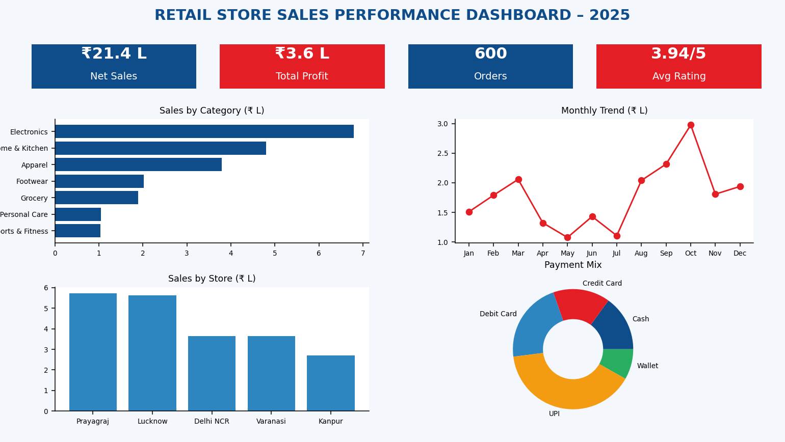
Figure 2: Cognos Dashboard – Overview

7.2 Net Sales by Product Category
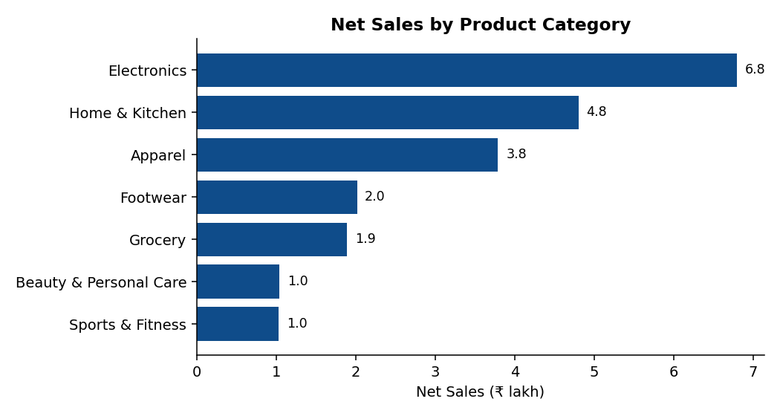
Figure 3: Net Sales by Product Category
Electronics is the largest category with net sales of ₹6.80 lakh (31.8% of total sales), followed by Home & Kitchen with ₹4.80 lakh and Apparel with ₹3.79 lakh. These three categories together contribute 72.0% of all sales. Grocery has the highest number of orders (186) but its sales value is much lower because the price per item is small. Beauty & Personal Care and Sports & Fitness are the smallest categories, each at around ₹1.03 lakh–₹1.04 lakh.

7.3 Monthly Sales Trend
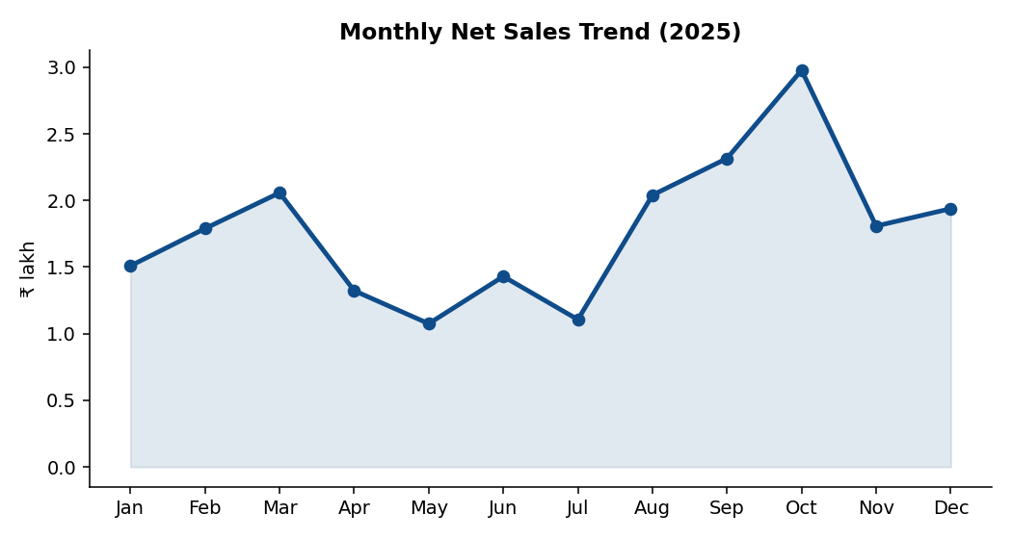
Figure 4: Monthly Net Sales Trend
Table 9: Monthly net sales and orders
Month | Orders | Net Sales (₹) | Profit (₹) | Margin
Jan 2025 | 46 | 1,50,938 | 29,869 | 19.8%
Feb 2025 | 41 | 1,78,935 | 28,911 | 16.2%
Mar 2025 | 49 | 2,05,782 | 35,349 | 17.2%
Apr 2025 | 40 | 1,32,302 | 21,980 | 16.6%
May 2025 | 39 | 1,07,539 | 16,715 | 15.5%
Jun 2025 | 38 | 1,43,007 | 22,366 | 15.6%
Jul 2025 | 42 | 1,10,625 | 18,676 | 16.9%
Aug 2025 | 60 | 2,04,016 | 39,324 | 19.3%
Sep 2025 | 65 | 2,31,591 | 44,793 | 19.3%
Oct 2025 | 77 | 2,97,787 | 41,755 | 14.0%
Nov 2025 | 57 | 1,80,840 | 26,889 | 14.9%
Dec 2025 | 46 | 1,93,857 | 31,659 | 16.3%

Sales were highest in October (₹2.98 lakh), when the festive season and special offers brought many customers. September (₹2.32 lakh) and March (₹2.06 lakh) were also strong. The weakest months were May (₹1.08 lakh) and July (₹1.11 lakh), which are the peak summer and monsoon months when store visits are lower. After the festive peak, sales fell in November and recovered a little in December because of year-end shopping.

7.4 Net Sales by Store Location
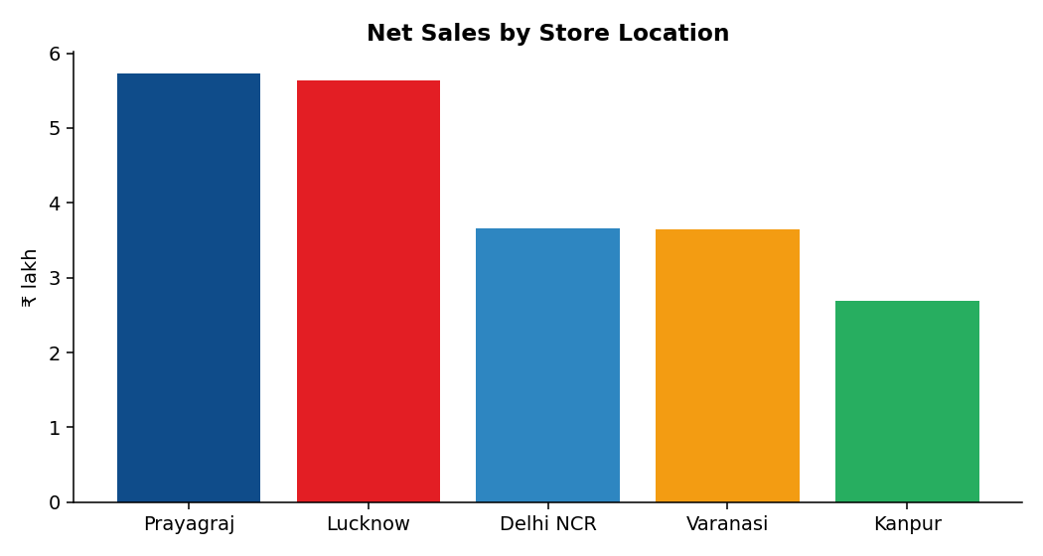
Figure 5: Net Sales by Store Location
Table 10: Store-wise performance
Store | Orders | Net Sales (₹) | Profit Margin | Avg Rating
Prayagraj | 163 | 5,73,127 | 16.1% | 3.82
Lucknow | 153 | 5,63,835 | 17.5% | 4.03
Delhi NCR | 99 | 3,65,796 | 18.4% | 3.93
Varanasi | 98 | 3,65,094 | 15.8% | 3.91
Kanpur | 87 | 2,69,367 | 15.5% | 4.08

Prayagraj (₹5.73 lakh) and Lucknow (₹5.64 lakh) are the two leading stores and together contribute 53.2% of total sales. Delhi NCR has fewer orders than these stores but earns the highest profit margin (18.4%), because customers there buy more high-value items. Kanpur has the lowest sales (₹2.69 lakh) and the lowest margin (15.5%), so it needs the most attention.

7.4A Store and Category Cross-analysis
Table 11: Net sales by store and category (₹ lakh)
Category | Prayagraj | Lucknow | Delhi NCR | Varanasi | Kanpur
Apparel | 1.00 | 0.91 | 0.92 | 0.57 | 0.38
Beauty & Personal Care | 0.18 | 0.39 | 0.03 | 0.29 | 0.15
Electronics | 2.32 | 1.26 | 0.97 | 1.50 | 0.75
Footwear | 0.53 | 0.69 | 0.22 | 0.29 | 0.27
Grocery | 0.46 | 0.53 | 0.30 | 0.24 | 0.36
Home & Kitchen | 0.86 | 1.58 | 1.16 | 0.56 | 0.64
Sports & Fitness | 0.37 | 0.27 | 0.06 | 0.20 | 0.14

The cross table shows how the strength of a category changes from store to store. Apparel sells most in Prayagraj; Beauty & Personal Care sells most in Lucknow; Electronics sells most in Prayagraj; Footwear sells most in Lucknow; Grocery sells most in Lucknow; Home & Kitchen sells most in Lucknow; Sports & Fitness sells most in Prayagraj. Such a view helps in deciding which store should receive extra stock of which category.

7.5 Customer Behaviour
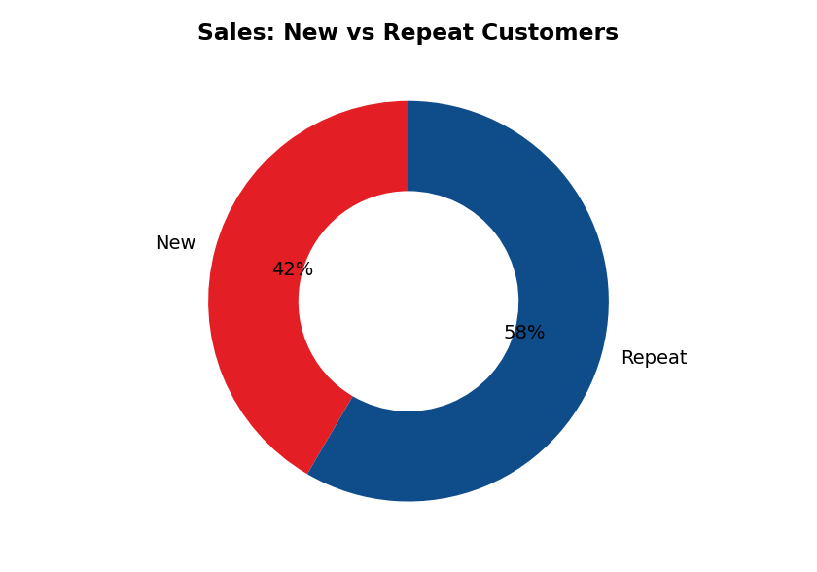
Figure 6: Sales: New vs Repeat Customers
Repeat customers generated ₹12.49 lakh (58.4% of sales) from 378 orders, while new customers generated ₹8.88 lakh from 222 orders. This shows that loyalty is the backbone of the business, but the large share of new customers also shows that the stores are able to attract fresh buyers.
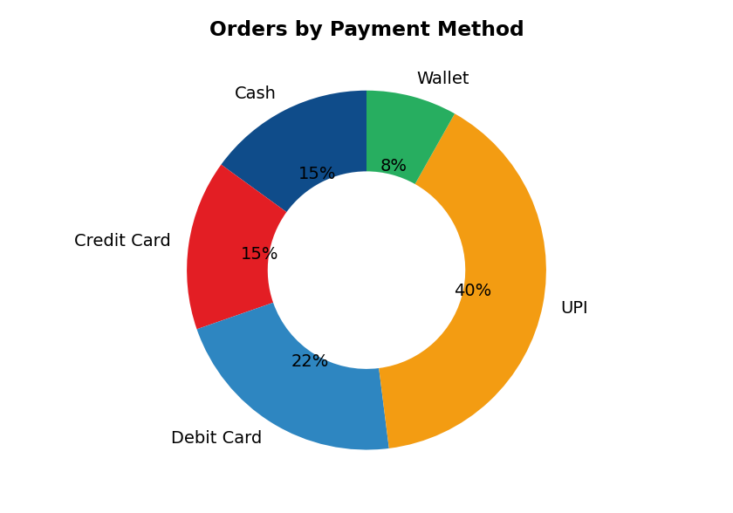
Figure 7: Orders by Payment Method
UPI is the most popular payment method with 239 orders (39.8%), followed by Debit Card (130 orders), Credit Card (92) and Cash (90). Wallets are used for only 8.2% of orders. The shift towards digital payments is clear, since cash accounts for only about one order in seven.
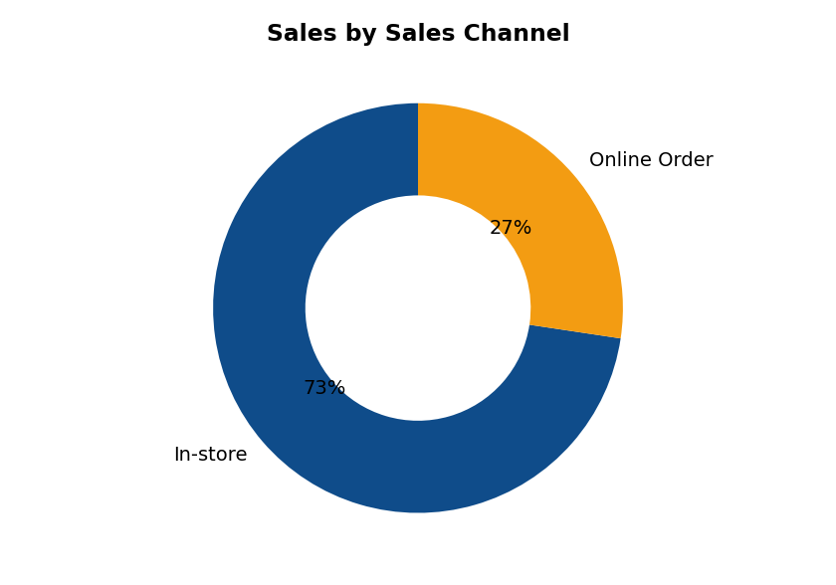
Figure 8: Sales by Sales Channel
In-store purchases make up 72.6% of sales and online orders (placed through the store app or phone and collected or delivered) make up 27.4%. Online orders have a slightly higher margin (17.2%) than in-store orders (16.6%).

7.6 Profitability Analysis
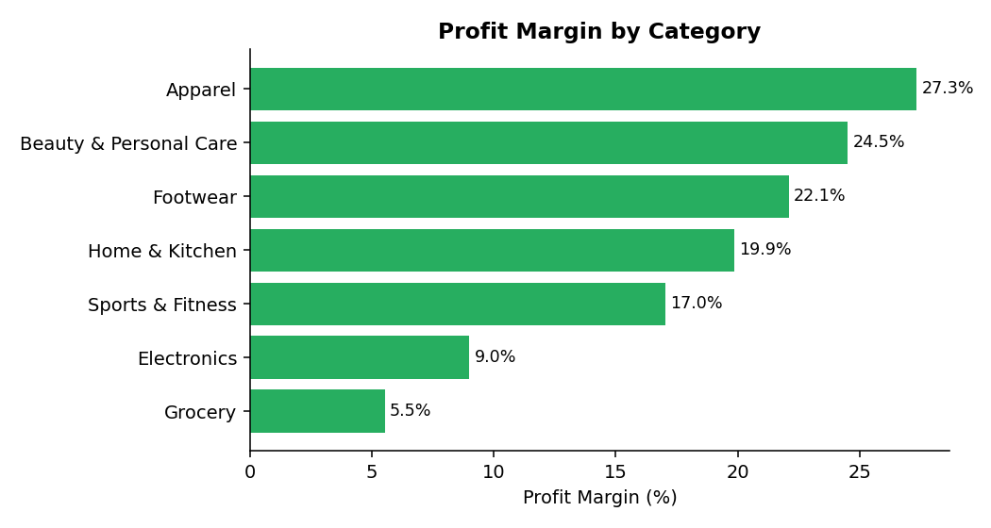
Figure 9: Profit Margin by Category
Table 12: Category-wise profit and margin
Category | Profit (₹) | Margin | Avg Discount | Avg Rating
Apparel | 1,03,637 | 27.3% | 9.1% | 4.12
Beauty & Personal Care | 25,499 | 24.5% | 9.3% | 3.96
Footwear | 44,547 | 22.1% | 8.9% | 3.79
Home & Kitchen | 95,397 | 19.9% | 8.2% | 3.84
Sports & Fitness | 17,568 | 17.0% | 9.8% | 3.90
Electronics | 61,151 | 9.0% | 8.2% | 4.01
Grocery | 10,487 | 5.5% | 9.2% | 3.90

There is a large difference between sales and profitability. Apparel has the highest margin (27.3%) followed by Beauty & Personal Care (24.5%) and Footwear (22.1%). Electronics, the biggest category by sales, earns only 9.0%, and Grocery earns just 5.5%. Even so, Electronics contributes ₹0.61 lakh of profit because of its huge sales volume.

7.7 Effect of Discounts
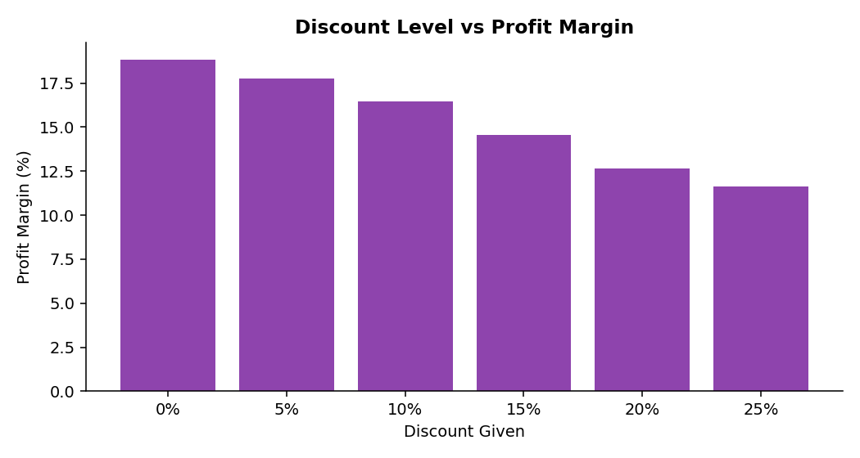
Figure 10: Discount Level vs Profit Margin
The profit margin falls steadily as the discount rises. Orders with no discount give a margin of 18.9%, while orders with a 20% discount give 12.6% and orders with a 25% discount give only 11.7%. In other words, moving from no discount to a 20% discount reduces margin by about 6.2 percentage points. Discounts should therefore be used carefully and only where they bring extra volume.

7.8 Customer Ratings
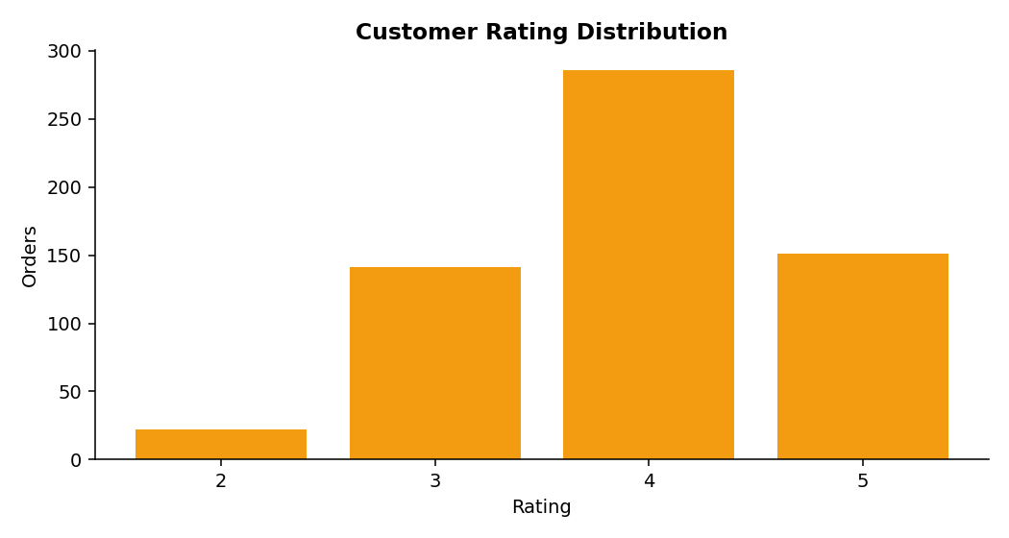
Figure 11: Customer Rating Distribution
The average rating is 3.94 out of 5. Ratings of 4 and 5 together make up 72.8% of all ratings, ratings of 3 make up 23.5% and ratings of 2 make up 3.7%. No order received a rating of 1. Footwear has the lowest average rating (3.79), which points to a quality or fitting issue that should be checked.

7.9 Predictive Model – Sales Forecast
To estimate future sales, a linear trend model was fitted to the twelve monthly sales values. The model has the form Sales = a + b × Month. The slope of the line is about ₹6,597 per month, which means that sales are slowly rising through the year. The model predicts the following sales for the first three months of 2026.
Table 13: Forecast of net sales (linear trend)
Month | Forecast Net Sales (₹) | Forecast (₹ lakh)
January 2026 | 2,20,983 | 2.21
February 2026 | 2,27,580 | 2.28
March 2026 | 2,34,177 | 2.34

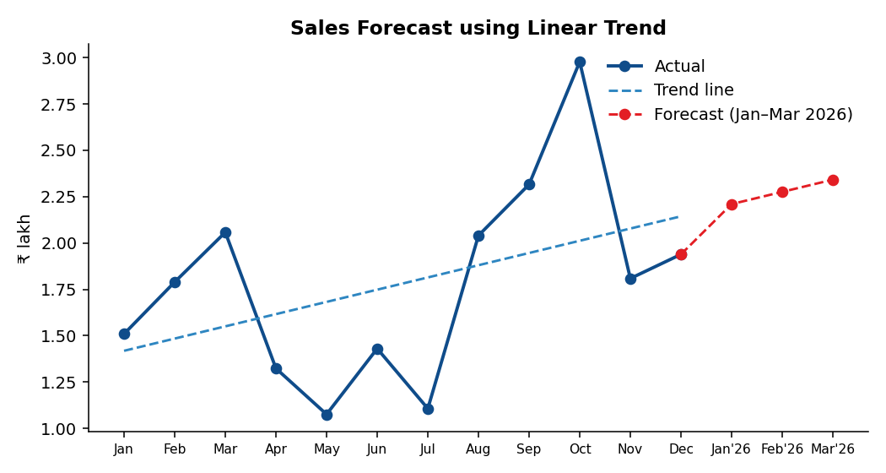
Figure 12: Sales Forecast using Linear Trend
The R² value of the trend line is 0.19, which means that only about 19% of the month-to-month variation is explained by the straight trend. The remaining variation is caused by seasonality, because the festive months raise sales well above the trend. The forecast should therefore be treated as a rough baseline. A seasonal model with two or more years of data would give a more accurate forecast.

8. INSIGHTS (OBSERVATIONS)
The key findings from the dashboard and the analysis are given below. They are grouped by theme so that they are easy to use in a management discussion.

8.1 Sales and Profit
- Total net sales were ₹21.37 lakh and total profit was ₹3.58 lakh, giving an overall margin of 16.8%.
- Electronics, Home & Kitchen and Apparel together generate 72.0% of the sales.
- High sales do not always mean high profit: Electronics has 31.8% of sales but only a 9.0% margin.
- Apparel has the best margin (27.3%) and is the most profitable per rupee of sales.
- Grocery brings the most footfall (186 orders) but the lowest margin (5.5%). It works as a traffic builder rather than a profit maker.

8.2 Time and Seasonality
- October is the peak month with ₹2.98 lakh of sales, about 2.8 times the sales of May.
- Sales are strong around March (year-end) and in the festive season (September–October).
- May and July are weak months when promotions can be used to lift footfall.

8.3 Stores
- Prayagraj and Lucknow are the strongest stores and give 53.2% of sales.
- Delhi NCR gives the best profit margin (18.4%) despite fewer orders.
- Kanpur is the weakest store in sales and margin.

8.4 Customers
- Repeat customers give 58.4% of the sales, so retention is very important.
- UPI is the leading payment method (39.8% of orders) and digital payments dominate over cash.
- Online orders give 27.4% of sales and are slightly more profitable than in-store orders.
- About 72.8% of customers give a rating of 4 or 5, but Footwear has a lower rating than other categories.

8.5 Discounts
- Every extra step of discount reduces margin; at 25% discount the margin falls to 11.7%.
- Festive discounts raise order count but reduce profit per order, so the discount level must be planned.
Table 14: Summary of key observations
Area | Observation | Meaning for the business
Category | Electronics leads in sales, Apparel in margin | Balance volume and profit
Month | October peak, May low | Plan stock and staff by season
Store | Prayagraj and Lucknow lead; Kanpur lags | Support weak store
Customer | Repeat customers dominate | Invest in loyalty
Payment | UPI is the top method | Keep digital payment smooth
Discount | Margin falls as discount rises | Control discount slabs

9. RECOMMENDATIONS / SUGGESTIONS
Based on the findings of this project, the following suggestions are given to the retail management.

9.1 Protect and grow high-margin categories
Give more shelf space and marketing support to Apparel, Beauty & Personal Care and Footwear because they earn margins of more than 20%. Cross-selling apparel with footwear can raise the basket value.

9.2 Improve Electronics profitability
Electronics brings the biggest sales but a low margin. Negotiate better prices with suppliers, sell accessories and extended warranties with each device, and avoid deep discounts on this category.

9.3 Use Grocery as a footfall driver
Keep Grocery prices attractive to bring customers into the store, but place high-margin items near the grocery section so that these customers also buy other categories.

9.4 Control the discount policy
Limit discounts above 15% to clearance stock and festive days. Use targeted offers such as “buy two get a small gift” instead of flat high discounts.

9.5 Plan inventory and staff by season
Increase stock and staff from August to October. Run summer and monsoon offers in May and July to reduce the sales gap.

9.6 Support the Kanpur store
Review the product mix, local competition and store layout of Kanpur. Use targeted local promotions and set a realistic monthly target with weekly tracking.

9.7 Learn from Delhi NCR
Study why Delhi NCR achieves a better margin and apply the same selling approach (premium product mix, less discounting) in other stores.

9.8 Build customer loyalty
Since repeat customers give most of the sales, start a points-based loyalty card, birthday offers and WhatsApp reminders. Convert new customers into repeat customers with a second-purchase coupon.

9.9 Promote digital payments and online orders
Offer small cashback on UPI or wallet payments and promote the online order option, which has a slightly better margin and growing demand.

9.10 Act on customer feedback
Investigate the lower ratings in Footwear (size, comfort, durability) and train staff to guide customers on fitting. Track ratings monthly on the dashboard.

9.11 Use the dashboard regularly
Review the Cognos dashboard every week in the management meeting, and connect it to the billing system so that data refreshes automatically.
Expected benefit
If the above steps are followed, the business can expect a better profit margin without losing sales volume, more stable sales across the year and a stronger base of loyal customers.

10. CONCLUSION AND FUTURE SCOPE

10.1 Conclusion
This project analysed the sales performance of a multi-store retail business using IBM Cognos Analytics. A dataset of 600 orders was created and prepared in Excel, loaded into Cognos, and used to build visualizations and a dashboard. The analysis answered the key questions raised in the problem statement.
The business earned net sales of ₹21.37 lakh and a profit of ₹3.58 lakh in 2025. Electronics was the largest category by sales, while Apparel gave the best profit margin. Prayagraj and Lucknow were the strongest stores, October was the best month and repeat customers contributed most of the revenue. UPI was the preferred payment method. The study also showed that higher discounts reduce profit margin sharply.
The project shows that a Business Intelligence tool can turn simple sales records into clear decisions. With a dashboard, managers do not need to read long tables; they can see strengths and weaknesses at once and act on them. The skills learnt in this project—data preparation, visualization, dashboard design and interpretation—are directly useful in business analytics careers.

10.2 Future Scope
- Use real transaction data from a retail chain instead of a created dataset.
- Add cost data (rent, salary, logistics) to calculate net profit instead of gross profit.
- Use a seasonal forecasting model with two to three years of data.
- Add customer segmentation (for example, high-value, regular and occasional customers) using RFM analysis.
- Connect Cognos directly to a live database for automatic daily refresh.
- Add market basket analysis to find products that are bought together.

GLOSSARY OF TERMS
Term | Meaning
BI (Business Intelligence) | Tools and methods that turn business data into useful information for decisions
Dashboard | A single screen that shows many charts and KPIs together
KPI | Key Performance Indicator – an important number used to track performance
Descriptive analytics | Analysis that summarises what has already happened
Net Sales | Sales amount after deducting discount
Profit Margin | Profit as a percentage of net sales
Average Order Value | Average amount spent per order
Data module | A prepared layer in Cognos that organises fields before reporting
Measure | A numeric field that can be added up, such as sales
Attribute | A field used to group data, such as store or category
Footfall | Number of customers visiting a store
Cross-selling | Selling a related product along with the main product
Seasonality | Regular rise and fall of sales in particular months
UPI | Unified Payments Interface – instant mobile bank payment system in India
Forecast | An estimate of future values based on past data
R² | Share of variation in data that is explained by the model

REFERENCES
- IBM Corporation. IBM Cognos Analytics Documentation – Getting Started with Dashboards. IBM Docs, www.ibm.com/docs.
- IBM Corporation. IBM Cognos Analytics – Data Modules and Visualizations (user guide).
- Kotler, P. & Keller, K. L. Marketing Management. Pearson Education.
- Levy, M. & Weitz, B. Retailing Management. McGraw-Hill Education.
- Few, S. Information Dashboard Design: Displaying Data for At-a-Glance Monitoring. Analytics Press.
- Evans, J. R. Business Analytics: Methods, Models and Decisions. Pearson Education.
- Microsoft. Microsoft Excel Help and Training. support.microsoft.com.
- Course material and lectures of the IBM programme, United University, Prayagraj.

APPENDIX – SAMPLE DATASET
The following table lists the first 190 records of the Retail Sales dataset. The complete dataset of 600 orders is provided in the Excel file Retail_Sales_Dataset.xlsx.
Order | Date | Store | Category | Qty | Disc | Net Sales | Profit | Payment | Cust. | Rtg
RS1001 | 01-01 | Lucknow | Footwear | 2 | 20.0% | 2,186 | 343 | Debit Card | Repeat | 4
RS1002 | 01-03 | Kanpur | Grocery | 2 | 10.0% | 693 | 31 | Credit Card | New | 3
RS1003 | 01-04 | Prayagraj | Grocery | 3 | 15.0% | 393 | -12 | Cash | New | 5
RS1004 | 01-05 | Delhi NCR | Electronics | 2 | 5.0% | 3,344 | 291 | Credit Card | Repeat | 4
RS1005 | 01-05 | Kanpur | Sports | 2 | 5.0% | 3,422 | 640 | UPI | Repeat | 2
RS1006 | 01-06 | Lucknow | Grocery | 4 | 0.0% | 2,420 | 56 | Cash | Repeat | 3
RS1007 | 01-06 | Kanpur | Footwear | 1 | 10.0% | 2,487 | 475 | Debit Card | Repeat | 4
RS1008 | 01-08 | Prayagraj | Grocery | 1 | 0.0% | 223 | 24 | UPI | Repeat | 4
RS1009 | 01-09 | Prayagraj | Beauty & PC | 2 | 20.0% | 2,117 | 340 | UPI | Repeat | 3
RS1010 | 01-10 | Prayagraj | Apparel | 3 | 0.0% | 8,715 | 2,353 | Cash | New | 2
RS1011 | 01-12 | Delhi NCR | Footwear | 2 | 0.0% | 6,330 | 1,668 | Credit Card | Repeat | 3
RS1012 | 01-12 | Varanasi | Grocery | 1 | 5.0% | 156 | 4 | Wallet | New | 3
RS1013 | 01-13 | Prayagraj | Sports | 1 | 10.0% | 2,202 | 440 | UPI | New | 4
RS1014 | 01-13 | Delhi NCR | Grocery | 2 | 10.0% | 740 | 69 | UPI | Repeat | 4
RS1015 | 01-13 | Prayagraj | Home & Kit. | 1 | 0.0% | 4,044 | 922 | Credit Card | New | 4
RS1016 | 01-13 | Varanasi | Footwear | 2 | 0.0% | 1,220 | 271 | UPI | Repeat | 2
RS1017 | 01-14 | Varanasi | Beauty & PC | 3 | 20.0% | 2,249 | 456 | Credit Card | Repeat | 4
RS1018 | 01-14 | Prayagraj | Footwear | 2 | 5.0% | 5,685 | 1,223 | UPI | Repeat | 4
RS1019 | 01-15 | Lucknow | Home & Kit. | 3 | 0.0% | 3,441 | 858 | Debit Card | Repeat | 4
RS1020 | 01-16 | Delhi NCR | Grocery | 1 | 0.0% | 603 | 47 | Debit Card | New | 4
RS1021 | 01-17 | Delhi NCR | Electronics | 2 | 10.0% | 6,998 | 250 | Debit Card | Repeat | 3
RS1022 | 01-18 | Delhi NCR | Grocery | 3 | 20.0% | 2,090 | 102 | UPI | New | 5
RS1023 | 01-19 | Prayagraj | Apparel | 4 | 0.0% | 11,120 | 3,645 | UPI | Repeat | 5
RS1024 | 01-19 | Varanasi | Home & Kit. | 2 | 0.0% | 6,830 | 1,741 | Debit Card | Repeat | 3
RS1025 | 01-19 | Kanpur | Apparel | 1 | 0.0% | 3,379 | 971 | Cash | New | 5
RS1026 | 01-19 | Kanpur | Grocery | 2 | 15.0% | 1,462 | -23 | Credit Card | New | 4
RS1027 | 01-20 | Delhi NCR | Footwear | 2 | 5.0% | 5,721 | 920 | Debit Card | New | 4
RS1028 | 01-20 | Kanpur | Apparel | 2 | 0.0% | 3,114 | 902 | UPI | Repeat | 3
RS1029 | 01-20 | Prayagraj | Grocery | 4 | 0.0% | 2,472 | 277 | Wallet | New | 5
RS1030 | 01-21 | Kanpur | Grocery | 2 | 20.0% | 1,366 | 78 | UPI | Repeat | 5
RS1031 | 01-21 | Kanpur | Grocery | 1 | 0.0% | 472 | 29 | Cash | Repeat | 4
RS1032 | 01-21 | Prayagraj | Grocery | 1 | 20.0% | 374 | -8 | Debit Card | Repeat | 4
RS1033 | 01-22 | Lucknow | Footwear | 1 | 15.0% | 1,633 | 360 | Debit Card | New | 5
RS1034 | 01-23 | Varanasi | Footwear | 1 | 20.0% | 1,370 | 176 | Wallet | Repeat | 3
RS1035 | 01-23 | Lucknow | Apparel | 4 | 10.0% | 5,396 | 1,361 | UPI | Repeat | 5
RS1036 | 01-23 | Prayagraj | Grocery | 2 | 0.0% | 1,770 | 219 | Cash | Repeat | 4
RS1037 | 01-24 | Kanpur | Footwear | 5 | 15.0% | 9,031 | 2,236 | Debit Card | Repeat | 4
RS1038 | 01-24 | Lucknow | Grocery | 3 | 20.0% | 2,021 | 77 | Cash | Repeat | 5
RS1039 | 01-24 | Delhi NCR | Grocery | 3 | 10.0% | 1,563 | 105 | Wallet | Repeat | 4
RS1040 | 01-24 | Delhi NCR | Home & Kit. | 3 | 20.0% | 6,758 | 1,078 | Debit Card | New | 4
RS1041 | 01-25 | Prayagraj | Electronics | 2 | 10.0% | 6,361 | 376 | Debit Card | New | 4
RS1042 | 01-26 | Prayagraj | Apparel | 2 | 0.0% | 4,710 | 1,467 | Cash | New | 4
RS1043 | 01-27 | Varanasi | Apparel | 1 | 10.0% | 1,129 | 340 | UPI | New | 4
RS1044 | 01-27 | Lucknow | Grocery | 1 | 0.0% | 638 | 50 | UPI | Repeat | 5
RS1045 | 01-27 | Varanasi | Apparel | 4 | 5.0% | 6,992 | 1,917 | Debit Card | New | 3
RS1046 | 01-27 | Lucknow | Home & Kit. | 1 | 10.0% | 3,498 | 724 | UPI | Repeat | 3
RS1047 | 02-01 | Varanasi | Electronics | 1 | 0.0% | 3,221 | 273 | Credit Card | Repeat | 4
RS1048 | 02-01 | Delhi NCR | Home & Kit. | 2 | 10.0% | 7,112 | 1,408 | UPI | Repeat | 3
RS1049 | 02-04 | Varanasi | Electronics | 2 | 10.0% | 8,471 | 564 | UPI | Repeat | 4
RS1050 | 02-04 | Lucknow | Sports | 3 | 10.0% | 8,100 | 1,511 | Debit Card | New | 4
RS1051 | 02-05 | Lucknow | Footwear | 1 | 15.0% | 1,950 | 390 | Cash | Repeat | 3
RS1052 | 02-07 | Varanasi | Electronics | 1 | 5.0% | 2,348 | 208 | UPI | Repeat | 5
RS1053 | 02-08 | Prayagraj | Grocery | 1 | 5.0% | 294 | 11 | Wallet | New | 4
RS1054 | 02-08 | Lucknow | Footwear | 2 | 20.0% | 1,698 | 339 | UPI | Repeat | 5
RS1055 | 02-09 | Varanasi | Beauty & PC | 2 | 5.0% | 2,981 | 766 | UPI | New | 3
RS1056 | 02-09 | Lucknow | Grocery | 3 | 0.0% | 1,779 | 143 | UPI | New | 5
RS1057 | 02-09 | Prayagraj | Grocery | 1 | 5.0% | 834 | 53 | UPI | Repeat | 3
RS1058 | 02-11 | Lucknow | Electronics | 2 | 0.0% | 14,376 | 1,540 | UPI | Repeat | 5
RS1059 | 02-11 | Lucknow | Beauty & PC | 5 | 10.0% | 8,001 | 2,082 | UPI | Repeat | 4
RS1060 | 02-11 | Delhi NCR | Grocery | 4 | 0.0% | 1,196 | 135 | Credit Card | Repeat | 4
RS1061 | 02-13 | Lucknow | Grocery | 5 | 15.0% | 3,676 | 308 | Credit Card | Repeat | 5
RS1062 | 02-14 | Lucknow | Home & Kit. | 3 | 5.0% | 11,742 | 2,362 | Debit Card | Repeat | 3
RS1063 | 02-14 | Kanpur | Grocery | 4 | 0.0% | 2,900 | 204 | UPI | Repeat | 5
RS1064 | 02-15 | Lucknow | Home & Kit. | 3 | 5.0% | 12,224 | 2,180 | Debit Card | New | 5
RS1065 | 02-16 | Delhi NCR | Grocery | 2 | 10.0% | 1,469 | 73 | Credit Card | New | 3
RS1066 | 02-17 | Delhi NCR | Apparel | 2 | 10.0% | 4,122 | 1,024 | Credit Card | Repeat | 4
RS1067 | 02-18 | Prayagraj | Grocery | 3 | 5.0% | 2,252 | 185 | Debit Card | Repeat | 4
RS1068 | 02-19 | Lucknow | Beauty & PC | 2 | 5.0% | 524 | 133 | UPI | Repeat | 5
RS1069 | 02-19 | Lucknow | Grocery | 1 | 20.0% | 275 | 8 | Cash | Repeat | 5
RS1070 | 02-19 | Prayagraj | Grocery | 1 | 5.0% | 479 | 27 | Cash | New | 3
RS1071 | 02-19 | Prayagraj | Grocery | 2 | 10.0% | 898 | 69 | UPI | New | 3
RS1072 | 02-19 | Prayagraj | Electronics | 2 | 0.0% | 14,678 | 1,252 | UPI | Repeat | 5
RS1073 | 02-20 | Lucknow | Beauty & PC | 3 | 10.0% | 2,246 | 490 | UPI | Repeat | 5
RS1074 | 02-23 | Delhi NCR | Apparel | 3 | 0.0% | 2,550 | 744 | UPI | Repeat | 5
RS1075 | 02-23 | Prayagraj | Grocery | 3 | 10.0% | 1,639 | 113 | Credit Card | Repeat | 5
RS1076 | 02-24 | Delhi NCR | Electronics | 2 | 0.0% | 17,868 | 1,577 | Debit Card | Repeat | 4
RS1077 | 02-24 | Delhi NCR | Apparel | 3 | 5.0% | 8,308 | 2,644 | Debit Card | Repeat | 2
RS1078 | 02-24 | Lucknow | Home & Kit. | 1 | 0.0% | 3,617 | 997 | Cash | Repeat | 4
RS1079 | 02-24 | Prayagraj | Home & Kit. | 1 | 0.0% | 836 | 195 | Credit Card | Repeat | 3
RS1080 | 02-25 | Lucknow | Grocery | 1 | 10.0% | 500 | 23 | UPI | Repeat | 4
RS1081 | 02-25 | Lucknow | Footwear | 3 | 0.0% | 6,444 | 1,483 | Debit Card | New | 3
RS1082 | 02-25 | Lucknow | Grocery | 3 | 0.0% | 834 | 58 | Wallet | New | 5
RS1083 | 02-26 | Delhi NCR | Home & Kit. | 2 | 15.0% | 6,174 | 1,229 | UPI | New | 5
RS1084 | 02-26 | Varanasi | Apparel | 1 | 20.0% | 2,699 | 784 | UPI | Repeat | 4
RS1085 | 02-26 | Kanpur | Grocery | 1 | 15.0% | 141 | 7 | Debit Card | Repeat | 4
RS1086 | 02-26 | Prayagraj | Footwear | 1 | 0.0% | 2,637 | 649 | Wallet | New | 3
RS1087 | 02-26 | Varanasi | Sports | 3 | 5.0% | 4,842 | 670 | Credit Card | Repeat | 2
RS1088 | 03-01 | Delhi NCR | Grocery | 2 | 5.0% | 509 | 28 | Credit Card | Repeat | 5
RS1089 | 03-01 | Lucknow | Footwear | 4 | 5.0% | 12,012 | 3,194 | Debit Card | Repeat | 4
RS1090 | 03-02 | Delhi NCR | Electronics | 2 | 0.0% | 12,416 | 1,777 | Debit Card | New | 4
RS1091 | 03-02 | Delhi NCR | Grocery | 1 | 0.0% | 369 | 35 | UPI | Repeat | 5
RS1092 | 03-02 | Delhi NCR | Footwear | 1 | 15.0% | 2,350 | 459 | Debit Card | Repeat | 4
RS1093 | 03-03 | Varanasi | Electronics | 1 | 15.0% | 3,332 | 169 | Debit Card | New | 4
RS1094 | 03-04 | Prayagraj | Grocery | 2 | 10.0% | 1,489 | 95 | UPI | Repeat | 4
RS1095 | 03-05 | Varanasi | Electronics | 2 | 10.0% | 10,912 | 622 | Credit Card | Repeat | 3
RS1096 | 03-05 | Delhi NCR | Home & Kit. | 2 | 0.0% | 6,260 | 1,684 | Wallet | Repeat | 4
RS1097 | 03-06 | Delhi NCR | Apparel | 3 | 5.0% | 6,743 | 1,736 | Cash | Repeat | 4
RS1098 | 03-06 | Varanasi | Grocery | 3 | 5.0% | 935 | 118 | UPI | Repeat | 4
RS1099 | 03-08 | Lucknow | Home & Kit. | 3 | 20.0% | 7,390 | 1,346 | UPI | Repeat | 4
RS1100 | 03-08 | Lucknow | Footwear | 3 | 0.0% | 9,288 | 2,749 | Cash | Repeat | 4
RS1101 | 03-09 | Kanpur | Grocery | 3 | 20.0% | 1,224 | 57 | UPI | Repeat | 3
RS1102 | 03-09 | Delhi NCR | Home & Kit. | 2 | 10.0% | 7,380 | 1,192 | UPI | Repeat | 4
RS1103 | 03-10 | Lucknow | Beauty & PC | 2 | 15.0% | 257 | 79 | Debit Card | Repeat | 3
RS1104 | 03-10 | Lucknow | Grocery | 1 | 0.0% | 276 | 3 | UPI | Repeat | 4
RS1105 | 03-10 | Varanasi | Electronics | 1 | 5.0% | 1,018 | 105 | UPI | Repeat | 4
RS1106 | 03-11 | Prayagraj | Home & Kit. | 2 | 10.0% | 2,669 | 424 | Credit Card | Repeat | 4
RS1107 | 03-12 | Delhi NCR | Grocery | 2 | 5.0% | 1,026 | 138 | Wallet | New | 4
RS1108 | 03-12 | Delhi NCR | Electronics | 2 | 20.0% | 2,706 | 175 | Credit Card | Repeat | 3
RS1109 | 03-12 | Varanasi | Beauty & PC | 1 | 0.0% | 1,596 | 464 | Debit Card | Repeat | 5
RS1110 | 03-13 | Lucknow | Electronics | 2 | 5.0% | 9,025 | 1,236 | UPI | New | 4
RS1111 | 03-13 | Prayagraj | Electronics | 1 | 10.0% | 6,990 | 380 | UPI | Repeat | 4
RS1112 | 03-14 | Lucknow | Home & Kit. | 3 | 0.0% | 13,164 | 2,787 | Credit Card | New | 4
RS1113 | 03-15 | Kanpur | Home & Kit. | 1 | 0.0% | 4,210 | 1,031 | Debit Card | New | 4
RS1114 | 03-17 | Prayagraj | Apparel | 4 | 20.0% | 9,856 | 2,643 | Debit Card | Repeat | 4
RS1115 | 03-17 | Delhi NCR | Electronics | 2 | 0.0% | 6,348 | 805 | Cash | Repeat | 4
RS1116 | 03-17 | Prayagraj | Electronics | 2 | 10.0% | 15,316 | 1,907 | Debit Card | Repeat | 4
RS1117 | 03-18 | Delhi NCR | Grocery | 1 | 20.0% | 222 | -5 | UPI | Repeat | 4
RS1118 | 03-18 | Varanasi | Home & Kit. | 1 | 15.0% | 2,246 | 310 | Cash | New | 4
RS1119 | 03-18 | Lucknow | Home & Kit. | 2 | 15.0% | 2,781 | 394 | Debit Card | Repeat | 4
RS1120 | 03-20 | Lucknow | Home & Kit. | 1 | 20.0% | 635 | 116 | Debit Card | New | 3
RS1121 | 03-21 | Delhi NCR | Home & Kit. | 1 | 20.0% | 3,092 | 465 | Cash | New | 3
RS1122 | 03-21 | Delhi NCR | Beauty & PC | 1 | 0.0% | 139 | 38 | UPI | Repeat | 4
RS1123 | 03-21 | Kanpur | Footwear | 2 | 0.0% | 6,312 | 1,158 | Cash | Repeat | 3
RS1124 | 03-23 | Varanasi | Electronics | 1 | 10.0% | 7,202 | 708 | Cash | Repeat | 5
RS1125 | 03-23 | Varanasi | Grocery | 2 | 0.0% | 608 | 20 | Credit Card | Repeat | 4
RS1126 | 03-24 | Lucknow | Sports | 4 | 0.0% | 4,692 | 997 | Debit Card | Repeat | 5
RS1127 | 03-24 | Lucknow | Grocery | 1 | 20.0% | 122 | -1 | UPI | New | 4
RS1128 | 03-24 | Prayagraj | Sports | 5 | 0.0% | 8,030 | 1,552 | Cash | New | 4
RS1129 | 03-25 | Prayagraj | Grocery | 4 | 10.0% | 1,793 | 60 | UPI | New | 5
RS1130 | 03-25 | Lucknow | Grocery | 1 | 10.0% | 590 | -0 | UPI | Repeat | 5
RS1131 | 03-26 | Kanpur | Apparel | 1 | 20.0% | 2,175 | 485 | Debit Card | Repeat | 4
RS1132 | 03-26 | Lucknow | Grocery | 4 | 0.0% | 2,636 | 243 | Cash | Repeat | 4
RS1133 | 03-27 | Prayagraj | Apparel | 1 | 5.0% | 2,040 | 659 | Cash | Repeat | 5
RS1134 | 03-27 | Lucknow | Beauty & PC | 3 | 10.0% | 1,312 | 328 | UPI | Repeat | 3
RS1135 | 03-27 | Prayagraj | Beauty & PC | 5 | 10.0% | 1,552 | 339 | Debit Card | New | 3
RS1136 | 03-27 | Prayagraj | Grocery | 1 | 0.0% | 537 | 45 | Cash | New | 4
RS1137 | 04-02 | Prayagraj | Grocery | 1 | 10.0% | 385 | 33 | UPI | Repeat | 5
RS1138 | 04-02 | Varanasi | Home & Kit. | 1 | 10.0% | 791 | 156 | UPI | Repeat | 3
RS1139 | 04-02 | Varanasi | Grocery | 1 | 15.0% | 148 | 10 | UPI | Repeat | 3
RS1140 | 04-03 | Varanasi | Beauty & PC | 1 | 5.0% | 306 | 78 | UPI | Repeat | 5
RS1141 | 04-04 | Delhi NCR | Home & Kit. | 5 | 5.0% | 7,125 | 1,501 | UPI | New | 4
RS1142 | 04-04 | Varanasi | Sports | 3 | 15.0% | 7,579 | 830 | Debit Card | New | 4
RS1143 | 04-04 | Lucknow | Apparel | 3 | 5.0% | 8,020 | 2,112 | UPI | Repeat | 4
RS1144 | 04-05 | Prayagraj | Electronics | 2 | 0.0% | 8,296 | 425 | UPI | Repeat | 4
RS1145 | 04-06 | Varanasi | Grocery | 4 | 0.0% | 1,012 | 93 | Cash | Repeat | 4
RS1146 | 04-07 | Kanpur | Footwear | 1 | 0.0% | 1,568 | 359 | Wallet | Repeat | 3
RS1147 | 04-08 | Delhi NCR | Apparel | 1 | 0.0% | 2,759 | 904 | UPI | New | 4
RS1148 | 04-08 | Delhi NCR | Electronics | 1 | 10.0% | 1,707 | 181 | Debit Card | Repeat | 4
RS1149 | 04-09 | Delhi NCR | Grocery | 4 | 5.0% | 1,170 | 133 | Debit Card | Repeat | 4
RS1150 | 04-09 | Delhi NCR | Grocery | 1 | 5.0% | 252 | 7 | Cash | New | 4
RS1151 | 04-12 | Varanasi | Sports | 1 | 5.0% | 1,562 | 291 | Credit Card | Repeat | 3
RS1152 | 04-12 | Delhi NCR | Grocery | 4 | 0.0% | 2,308 | 255 | Debit Card | Repeat | 4
RS1153 | 04-13 | Lucknow | Grocery | 1 | 10.0% | 684 | 20 | Debit Card | Repeat | 5
RS1154 | 04-13 | Varanasi | Electronics | 2 | 0.0% | 15,282 | 2,642 | UPI | Repeat | 3
RS1155 | 04-13 | Kanpur | Apparel | 2 | 15.0% | 4,298 | 1,011 | Wallet | Repeat | 5
RS1156 | 04-14 | Prayagraj | Home & Kit. | 1 | 0.0% | 1,820 | 383 | Wallet | Repeat | 4
RS1157 | 04-15 | Delhi NCR | Grocery | 2 | 15.0% | 292 | 14 | Debit Card | Repeat | 4
RS1158 | 04-15 | Kanpur | Electronics | 1 | 0.0% | 7,845 | 646 | UPI | New | 5
RS1159 | 04-15 | Lucknow | Apparel | 2 | 5.0% | 6,580 | 1,615 | Cash | New | 5
RS1160 | 04-15 | Varanasi | Grocery | 1 | 0.0% | 818 | 41 | Wallet | Repeat | 2
RS1161 | 04-16 | Lucknow | Beauty & PC | 1 | 15.0% | 1,164 | 306 | Credit Card | New | 5
RS1162 | 04-17 | Lucknow | Apparel | 1 | 0.0% | 2,029 | 660 | Debit Card | New | 5
RS1163 | 04-17 | Lucknow | Apparel | 1 | 10.0% | 1,169 | 319 | Cash | Repeat | 4
RS1164 | 04-18 | Kanpur | Sports | 3 | 15.0% | 6,411 | 1,237 | Wallet | New | 4
RS1165 | 04-19 | Delhi NCR | Electronics | 1 | 15.0% | 4,137 | 116 | Cash | Repeat | 4
RS1166 | 04-19 | Lucknow | Electronics | 2 | 15.0% | 4,602 | 150 | Credit Card | Repeat | 3
RS1167 | 04-21 | Prayagraj | Beauty & PC | 1 | 0.0% | 1,630 | 439 | UPI | New | 3
RS1168 | 04-23 | Lucknow | Home & Kit. | 5 | 20.0% | 17,472 | 3,480 | Credit Card | Repeat | 3
RS1169 | 04-23 | Prayagraj | Home & Kit. | 2 | 0.0% | 2,930 | 709 | Cash | New | 5
RS1170 | 04-23 | Lucknow | Grocery | 2 | 10.0% | 1,170 | 69 | UPI | Repeat | 2
RS1171 | 04-25 | Varanasi | Home & Kit. | 4 | 10.0% | 2,574 | 476 | Cash | Repeat | 3
RS1172 | 04-25 | Kanpur | Beauty & PC | 1 | 15.0% | 325 | 73 | Debit Card | New | 4
RS1173 | 04-26 | Prayagraj | Sports | 1 | 15.0% | 551 | 109 | Cash | Repeat | 5
RS1174 | 04-27 | Kanpur | Grocery | 3 | 5.0% | 1,123 | 88 | Credit Card | Repeat | 4
RS1175 | 04-27 | Lucknow | Grocery | 3 | 20.0% | 545 | 1 | Credit Card | New | 3
RS1176 | 04-27 | Delhi NCR | Grocery | 4 | 15.0% | 1,863 | 8 | Cash | Repeat | 4
RS1177 | 05-02 | Prayagraj | Electronics | 2 | 5.0% | 11,626 | 1,739 | UPI | New | 3
RS1178 | 05-02 | Lucknow | Sports | 2 | 10.0% | 1,895 | 313 | UPI | Repeat | 4
RS1179 | 05-02 | Lucknow | Apparel | 2 | 15.0% | 4,036 | 1,039 | Debit Card | Repeat | 4
RS1180 | 05-02 | Varanasi | Home & Kit. | 1 | 0.0% | 3,487 | 779 | Cash | Repeat | 5
RS1181 | 05-03 | Prayagraj | Home & Kit. | 4 | 5.0% | 4,807 | 835 | Debit Card | New | 4
RS1182 | 05-05 | Varanasi | Grocery | 1 | 5.0% | 578 | 33 | Credit Card | Repeat | 3
RS1183 | 05-05 | Prayagraj | Grocery | 1 | 5.0% | 402 | 22 | Wallet | New | 3
RS1184 | 05-05 | Varanasi | Grocery | 3 | 0.0% | 1,794 | 114 | UPI | New | 5
RS1185 | 05-05 | Kanpur | Home & Kit. | 1 | 0.0% | 4,264 | 966 | Cash | Repeat | 3
RS1186 | 05-05 | Lucknow | Electronics | 1 | 20.0% | 2,772 | 237 | Cash | Repeat | 4
RS1187 | 05-06 | Delhi NCR | Beauty & PC | 3 | 15.0% | 1,242 | 288 | Credit Card | New | 4
RS1188 | 05-06 | Kanpur | Grocery | 2 | 10.0% | 1,609 | 96 | Credit Card | Repeat | 4
RS1189 | 05-06 | Prayagraj | Electronics | 2 | 20.0% | 9,235 | 554 | UPI | Repeat | 4
RS1190 | 05-08 | Kanpur | Grocery | 4 | 5.0% | 3,397 | 95 | Credit Card | Repeat | 3

